**AWS Basic Assignment**

*29/12/2025*

**Chandan Mishra**

GitHub Link- <https://github.com/ChandanNagarro/AwsBasicAssignment.git>

1. Create a VPC with at least two subnets (one public, one private)Ans: Screenshots

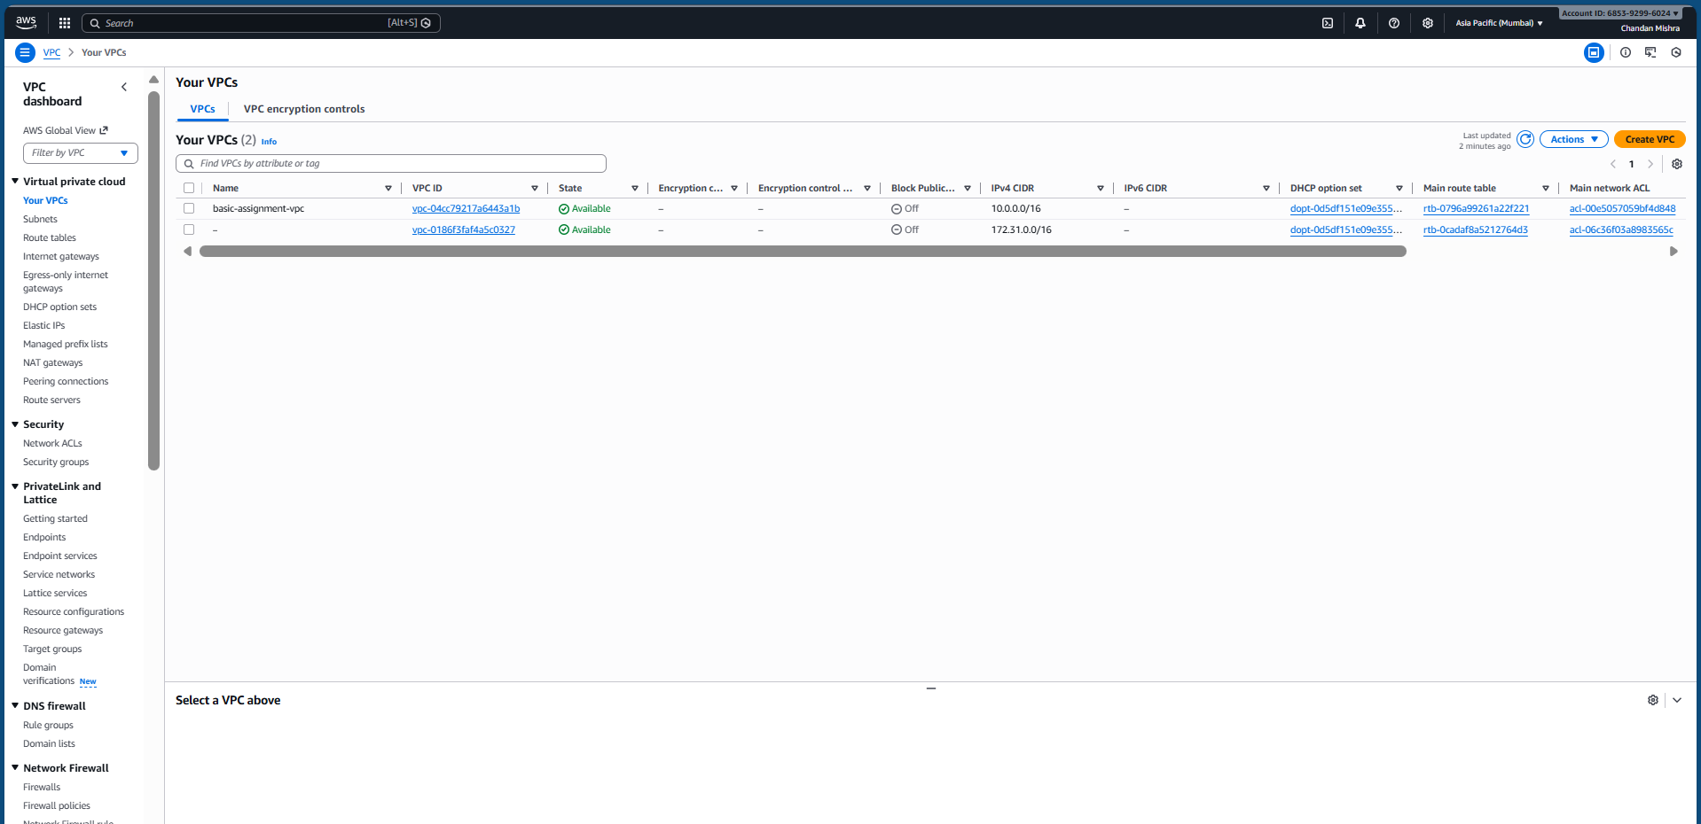

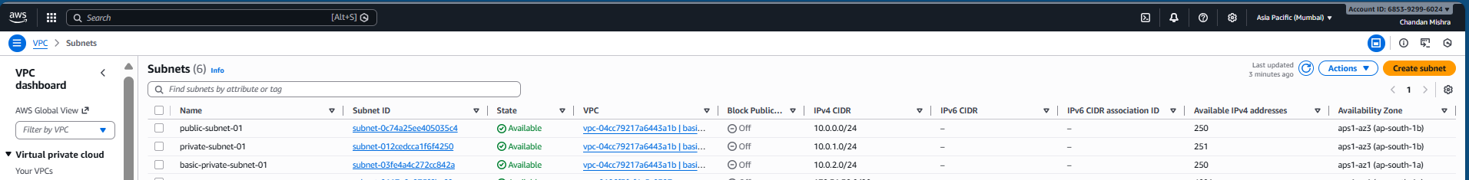

2. Create Elastic Beanstalk and deploy any sample web application

Ans: Screenshots

**Sample Application deployment on elastic bean**

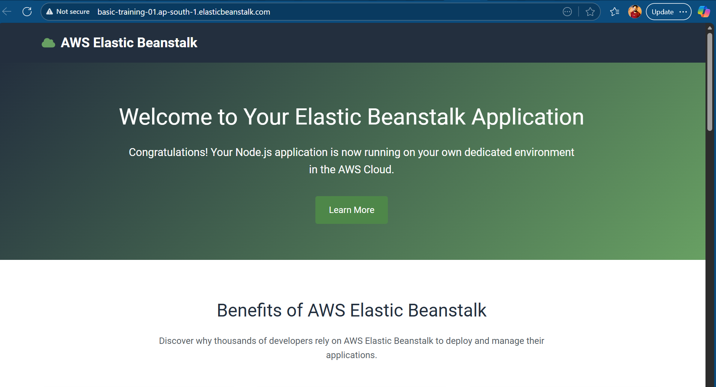

3. Create an Amazon RDS Database (use db.t3.micro or db.t4g.micro for free tier) in private subnet

Ans: Screenshots

4. Configure security groups to allow EBS to access RDS

Ans: Screenshots

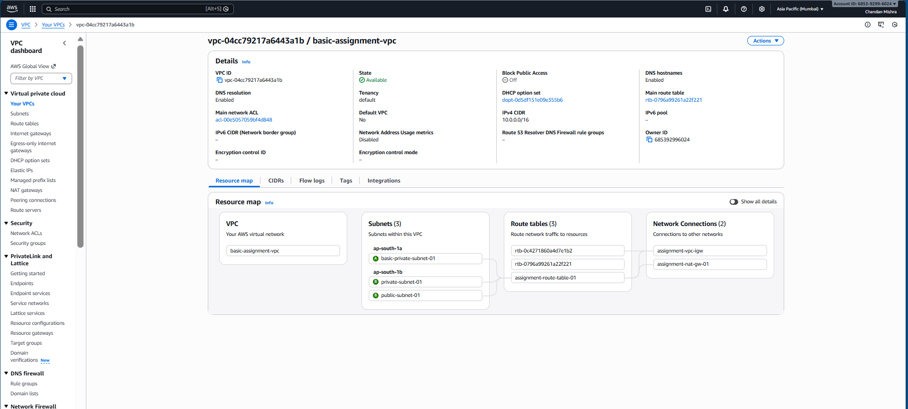

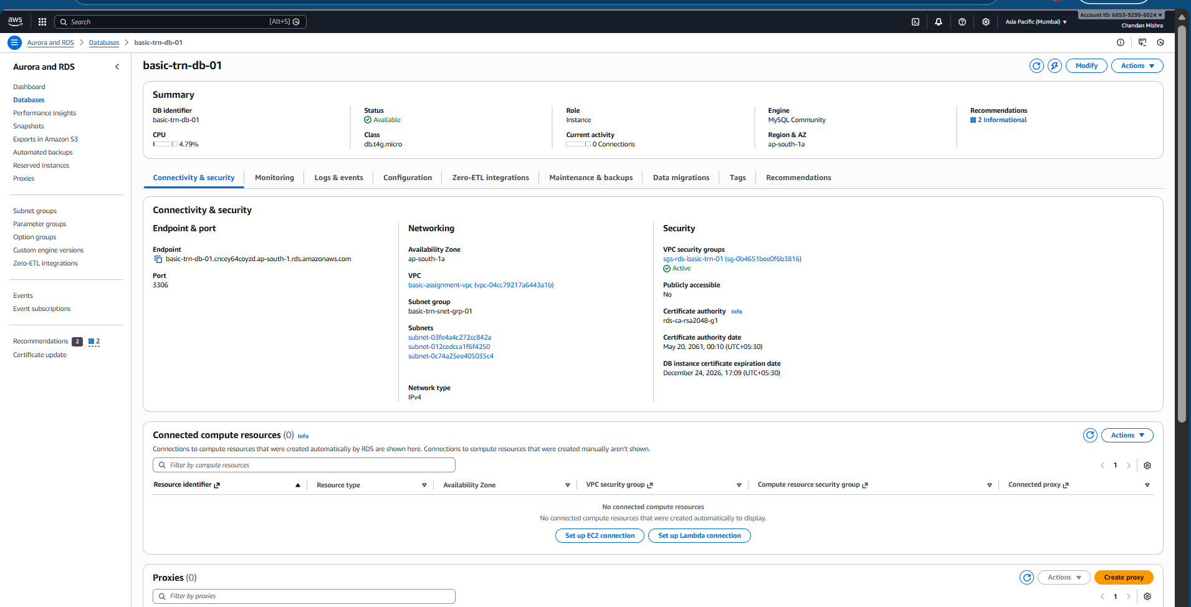

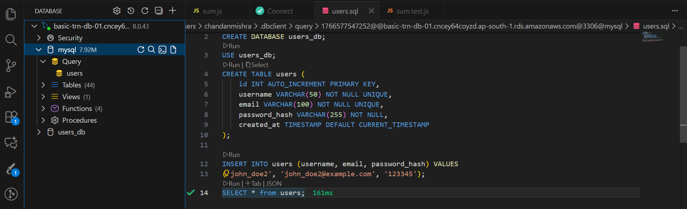

Private Data base 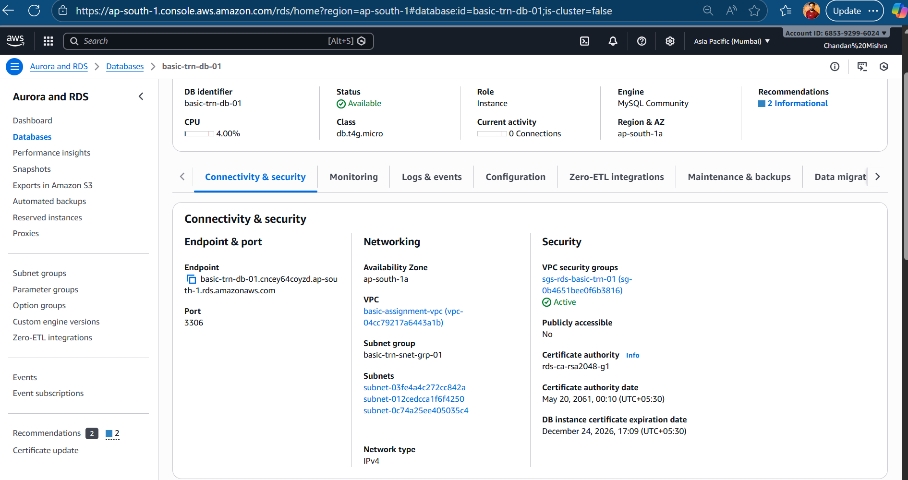 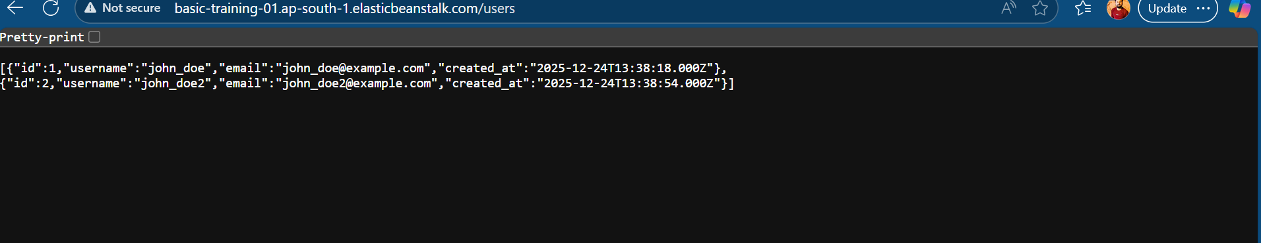

5.Create an S3 bucket and configure it to trigger SQS when a file is uploaded

Ans: Screenshots

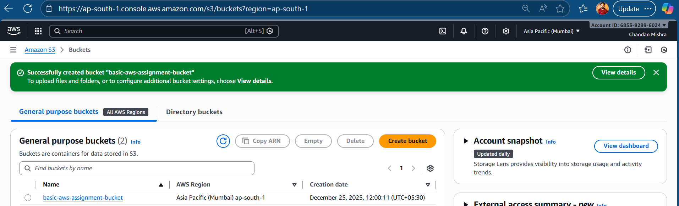

6. Create Lambda function to trigger on SQS messages and write logs to CloudWatch

Ans: Screenshots

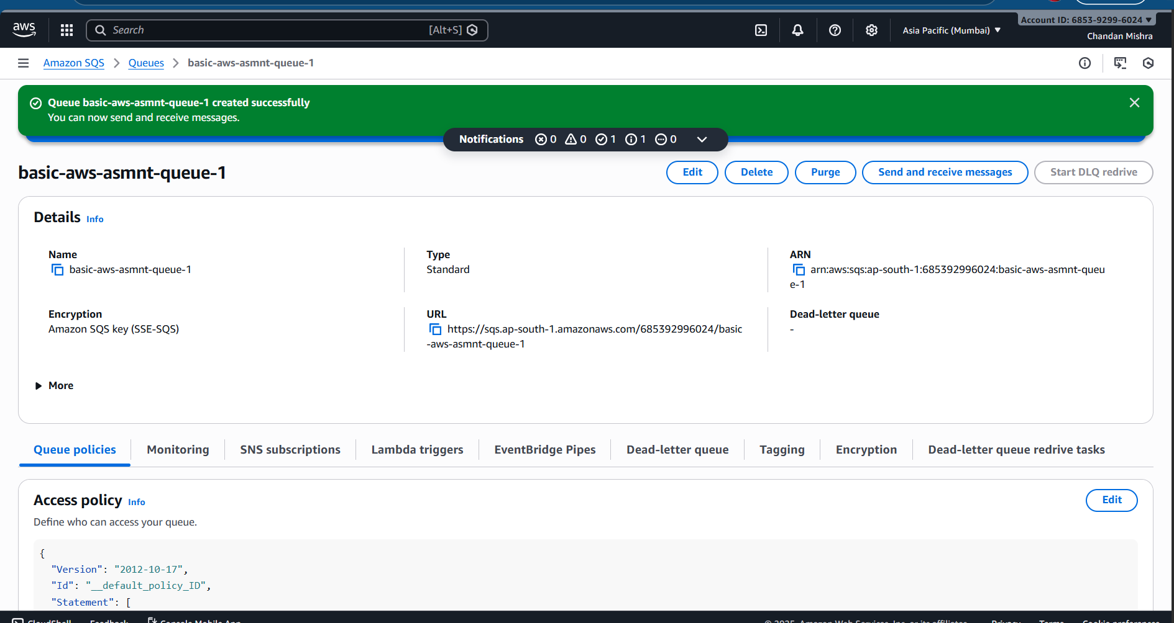

7. Configure S3 bucket policies for public read access to static files

Ans: Screenshots

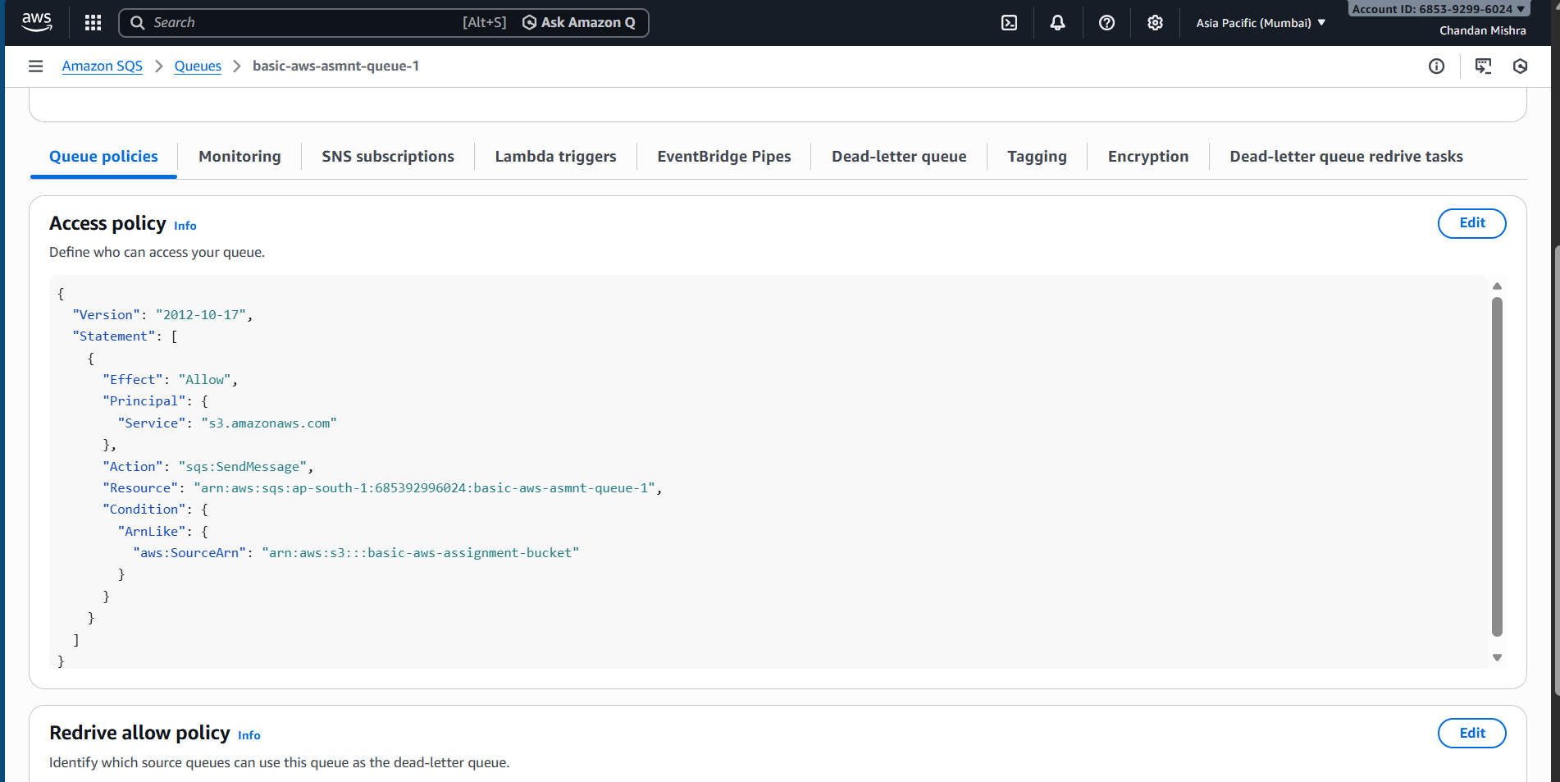

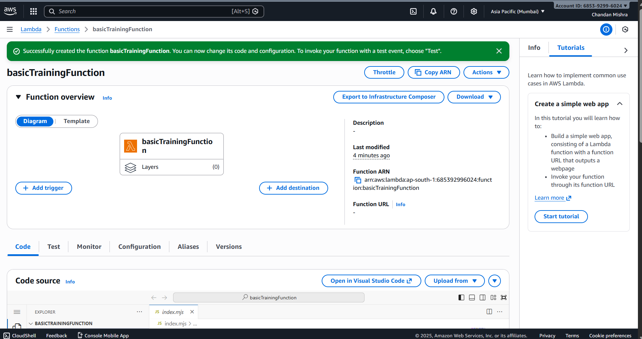

8. Set up CloudWatch monitoring on EBS and RDSAns: Screenshots

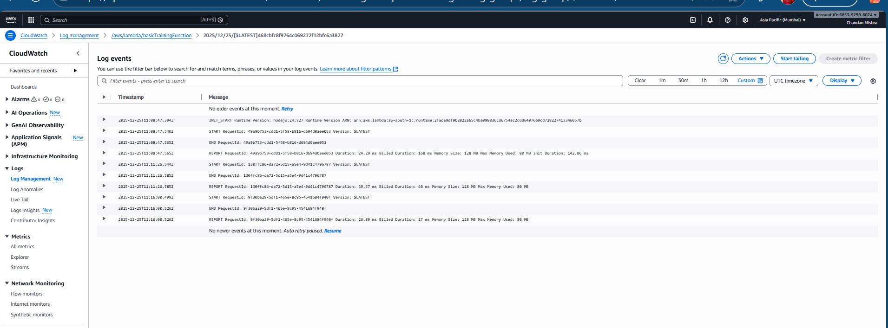

//block public access

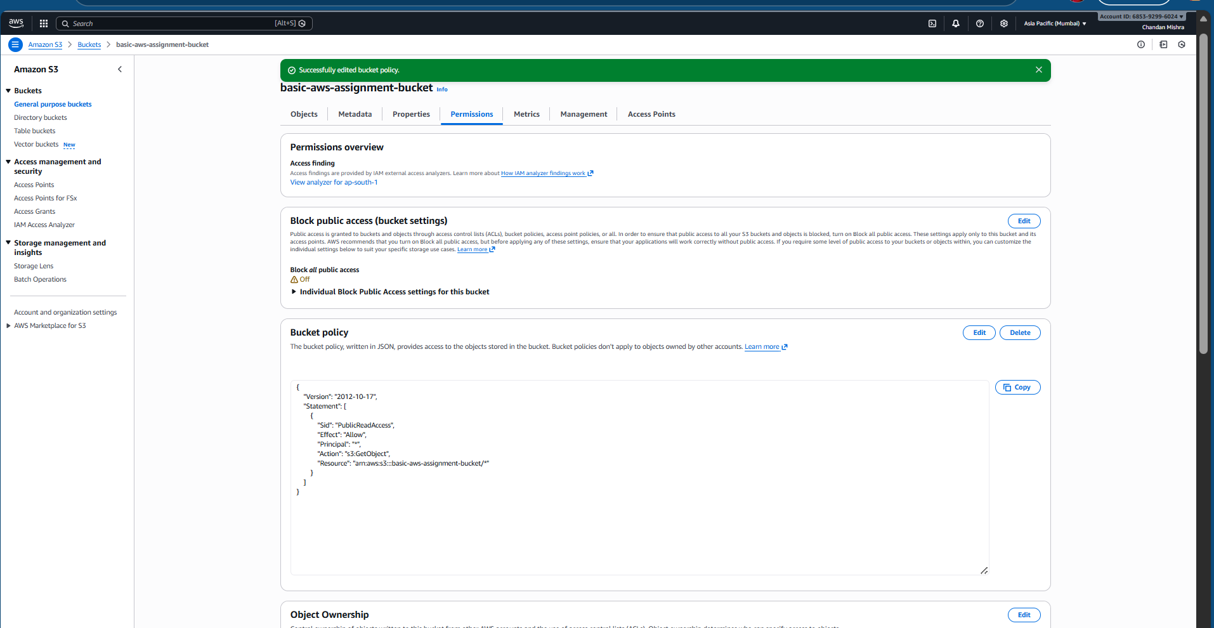

9.Create CloudWatch alarms for CPU utilization on EBS and RDS

10. Review CloudWatch Logs for EBS environment logsAns: Screenshots

